**Assignment** **1** **-** **Git** **and** **GitHub**

**DEADLINE: Wednesday, September 20, 2023 at 11:59PM on Canvas.**

**DELIVERABLE:** A .pdf file containing the answers and screenshots for the questions and tasks below, submitted on Canvas by the deadline.

**Objectives:**

• Familiarize yourself with version control systems, Git commands, and GitHub

**1. Complete the following version control and Git training in LinkedIn Learning and obtain a certificate with your name on it (2h 55min):** https:/[/www.linkedin.com/learning/git-essential-training-the-basics](http://www.linkedin.com/learning/git-essential-training-the-basics)

To access LinkedIn Learning for free, login to my.fsu.edu, then choose “Resources” in the left menu, and “LinkedIn Learning Online Training”. LinkedIn Learning is free to all FSU students and employees.

Make sure you follow the training along, by installing git on your computer and then performing the commands on your computer. Among the first 3 subsections in section 2 (2.1 -2.3), you only need to watch the one corresponding to your OS platform.

Obtain the certificate for completing the training and include it in the submission. (**40 points**).

**2. Access “Learn Git Branching”** https://learngitbranching.js.org/ **and complete at least the following levels:**

a) Main – Introduction Sequence (**10 points**)

b) Remotes – Push & Pull -- Git Remotes! (**10 points**)

Take screenshots showing you completed the two trainings and copy-paste them in your assignment file.

**3. Access “Visualizing Git”** <http://git-school.github.io/visualizing-git/>, **and execute the following commands in order to see how the repository changes:**

a) git log

b) git commit c) git commit

d) git commit -m=“third”

e) git branch dev

f) git commit -m=“commit master”

g) git checkout dev

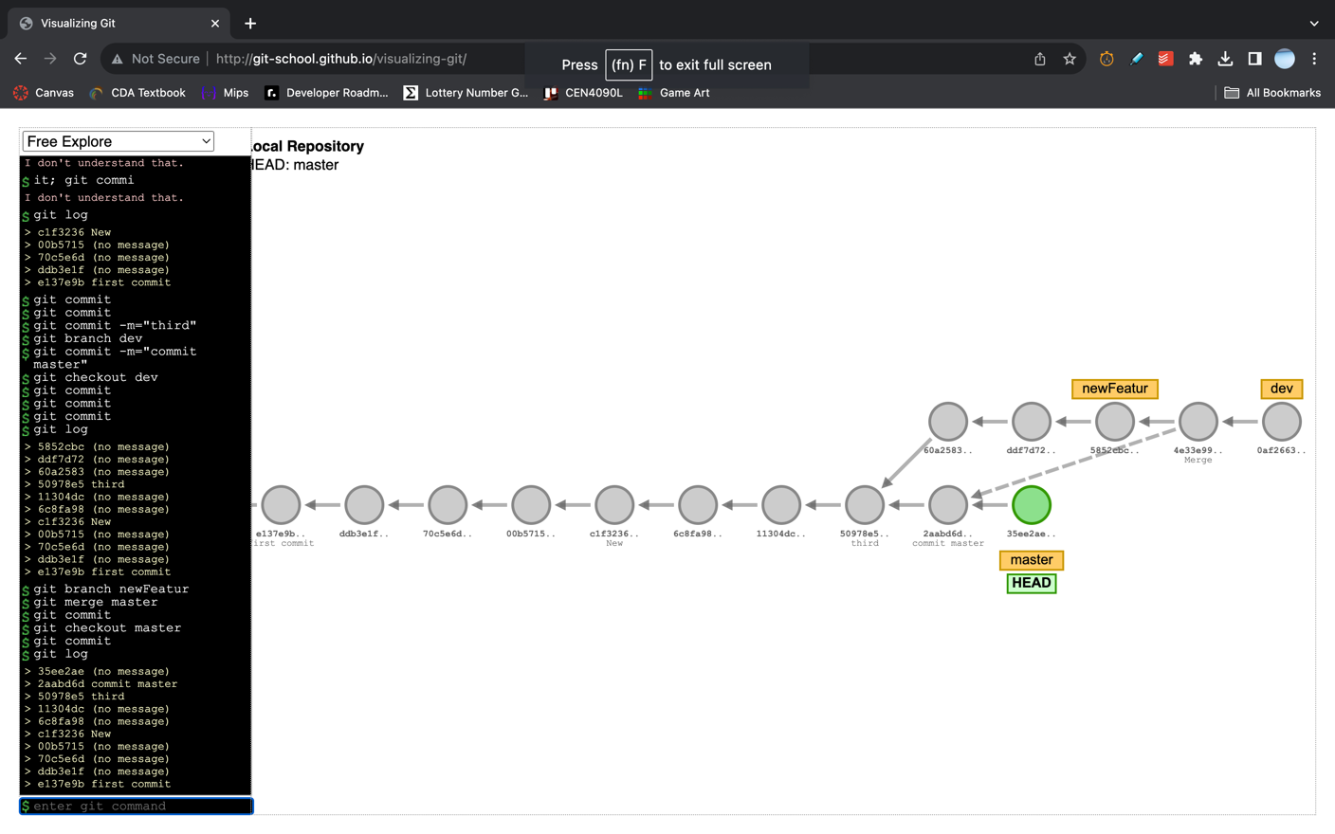h) git commit

i) git commit j) git commit k) git log

l) git branch newFeature

m) git merge master n) git commit

o) git checkout master p) git commit

q) git log

Take a screenshot of your screen after completing the training, showing the entire page, with the commands you executed and the visualizations. (**10 points**)

**4. Answer the following questions:**

a) What is a version control system? (**3 points**) A way to manage and view changes made to the directory over time. This can be seen as the history in a word document.

b) What is the difference between distributed version control systems and centralized version control systems? (**3 points**) A distributed control system allows for the individuals working on the project to make their own copies on their local device and then commit it to the main repository. A central control system the other repositories are still contained within the central one. So there is a single point of failure.

c) Explain the three trees architecture in Git. (**3 points**)

The working directory is where the changes get tracked by git

The staging index contains changes that will be commited to the repository

The repository is the final stage that is tracked by git.

d) What is a **.gitignore** file? (**3 points**) It tells git to track specified files/ directories/etc or not.

e) What is the Git command you can use to compare two commits? (**3 points**)

git diff

f) What is the HEAD pointer in Git and how does it move around? (**3 points**)

It is a reference to the most recent commit, it moves around as new commits are made.

g) Why is it important to make atomic commits? (**3 points**) We can easily reverse any errors, and decreases the likelihood of fatal errors.

h) What Git command can you use to undo changes to a file in your working directory? (**3 points**) git checkout

i) What Git command can you use to revert a commit? (**3 points**) git revert

**5.** Create a GitHub account at https://github.com (if you don't have one already) and copy- paste your GitHub username in your assignment as an answer to this question. (**3 points**)

Awa03 - https://github.com/awa03

**Additional resources**: You can look up more tutorials at <http://try.github.io/>